Use-Case Realization Report
UpdateRole

Issue <1.0>
Revision History
Date | Issue | Description | Author
<dd/mmm/yy> | <x.x> | <details> | <name>

Table of Contents
1. Brief Description 4
2. Flow of Events 4
3. Interaction Diagrams 4
3.1 Collaboration Diagram for UpdateRole 4
3.2 Sequence Diagram for UpdateRole 5
4. Participating Objects 5
5. Class Diagrams 7
5.1 Class Diagram for UpdateRole 7
6. Derived Requirements 7

Use-Case Realization Report
UpdateRole

Brief Description

Flow of Events
[enter the flow of events here; you can use subsections to structure the text]

Interaction Diagrams

Collaboration Diagram for UpdateRole
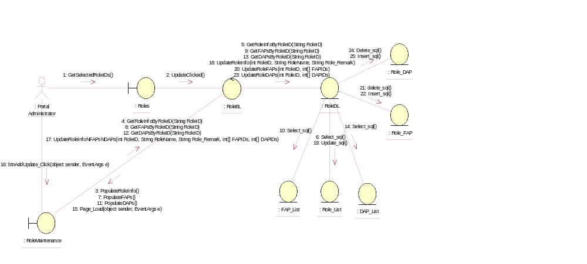

Sequence Diagram for UpdateRole
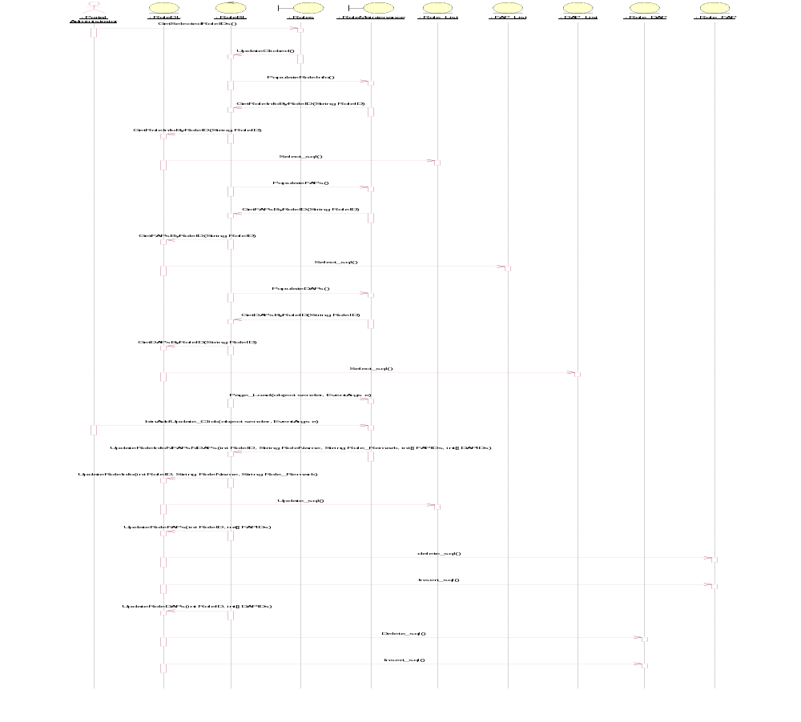

Participating Objects
: DAP_List

: FAP_List

: Portal Administrator

: Role_DAP

: Role_FAP

: Role_List

: RoleBL

: RoleDL

: RoleMaintenance

: Roles

Class Diagrams

Class Diagram for UpdateRole
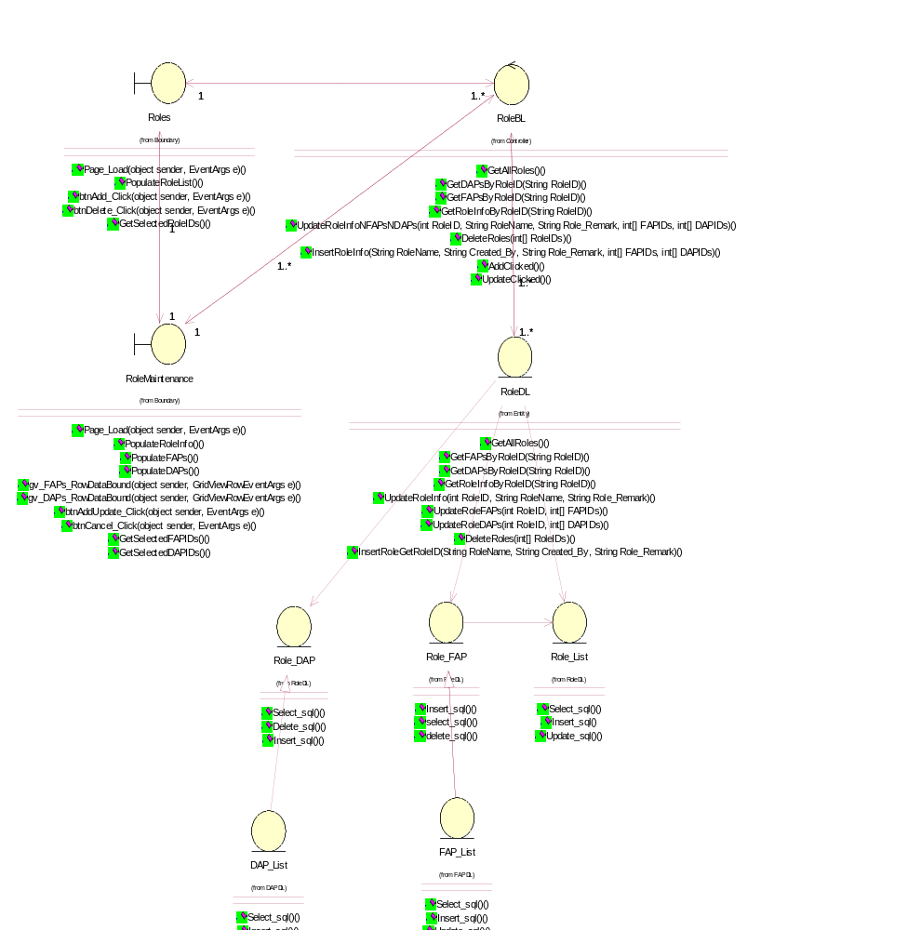

Derived Requirements
[enter the derived requirements here]

